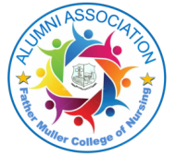
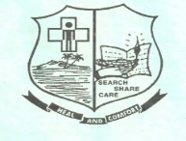
FATHER MULLER COLLEGE OF NURSING
(A Unit of Father Muller Charitable Institutions)
Kankanady, Mangalore-575002
ALUMNI ASSOCIATION
Teachers Day Celebration -2025
Alumni Association of Father Muller College of Nursing in collaboration with the Students Nurses Council organized. teacher’s day celebration on 5 September 2025 to honour and appreciate the invaluable contributions of the teaching fraternity. The formal inauguration of the program commenced at 9.30 am with a soulful prayer song rendered by the nursing students, setting a serene and reflective tone for the day.
Rev Fr Foustine Lucas Lobo Director Father Muller Charitable institutions graced the occasion as the chief guest. As a mark of gratitude and recognition, the Alumni Association felicitated teachers who have rendered ten or more years of dedicated service and are proud alumni of Father Muller College of Nursing. A total of eight faculty members were honoured on this special occasion:
- Dr Shiji PJ, Professor, Department of Community Health Nursing, 17 years of experience
- Mrs Wilma Shalini Noronha, Professor, Department of Child Health Nursing -15 years of experience
- Mr Manoj PS, Associate Professor, Department of Child Health Nursing 15 years of experience
- Ms Anitha Nancy Dsouza,Assistant Lecturer,Department of Nursing Foundation 15 years of experience
- Mrs Nathalia Martis,Assistant Lecturer,Department of Medical Surgical Nursing 15 years of experience
- Dr Sonia Karen Liz Sequera, Professor, Community Health Nursing 13 years of experience
- Mrs Sonia A Dsouza,Assistant Lecturer,Department of MedicalSurgical Nursing 14 years of experience
- Ms Precilla loriena Dsouza, Professor, Department of Obstetrics and Gynaecological Nursing, 13 years of experience
The celebration served as a heartfelt expression of appreciation for the teachers’ unwavering commitment, guidance, and contribution to the growth and excellence of the institution.
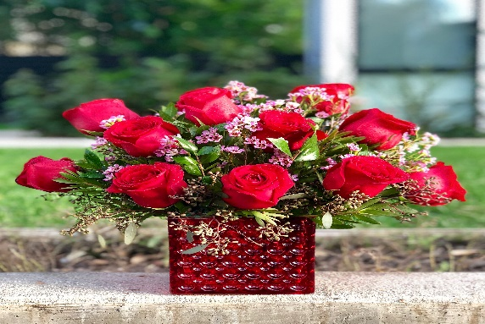
Congratulations

